DCM Name | DCM Outcome Identification Bathing
DCMType: | Procedure
DCMiD:
DCM Oid:
DCM Repository Id:
File name | 0000.doc
Version doc.: | 0.2
Code/Keyword: | Bathing, limitations in bathing, drying, method of bathing
Language: | English
Publication Status: | Status: | Date:
Publication Status: | Author Draft(en);  Committee Draft(en);  Organisation Draft(en);  Submitted(en);  Withdrawn  Rejected(en)  Obsolete  Approved for testing  Approved for Production Use  Superseded | 04-01-2010
Authors: | Drs. A.T.M. Goossen, Dr. W.T.F. Goossen, Drs. Y.J. Koster-de Jong. Results 4 Care.
Contact information : | Results4Care@cs.com
Requirement specification and Review of content
Endorsing Authority
Verification and Validity
Quality label/ Certification

Copyrights: | Licenses of source material  Not applicable  Use of the DCM  The DCM is open source, so free to use, not to be changed.  Changes in the content en codes are seen upon as a infringement of copyright and is damaging for the goal of use: realisation of semantic interoperability.  You can suggest changes at results4care@cs.com  Revision suggestions will be looked at and may lead to:  - revised DCM and results if accepted  - variations of the DCM adapted on a local situation.  This is all based upon : a “common ownership” but not a “special stewardship”.
DCM Format
Additional formats | HL7 template  Archetype  Zorginformatiemodel  Plain XML

Version management
version | date | Changes | Reason of change | author
0.3
0.2 | 04-01-2010 | Textual adjustments | Review | Dr. William Goossen
0.11 | 20-05-2009 | First Draft |  | Drs. Y.J. Koster- de Jong, Results 4 Care.

Purpose
The client is bathed in a way that suits his personal needs and self care options / limitations. The self care deficit in bathing is discontinued or compensated.

Evidence based
Personal care is the support in daily care. Bathing (showering) is a part of the personal care. The bathing of the own body is part of the nursing process. Bathing is an act that takes place during the contacts between the nurse and the patient. The bathing is a also a part of the nursing plan (Kruiswijk Jansen, 1994). In this DCM the outcome and expected outcome are identified.
If we draw the outcome of bathing with the RUMBA requirements we will see that:
The patient is able to bathe his own body independently with or without assistive devices.
R (Relevant): de patient
U (Understandable): subject is the bathing of one’s own body
M (Measureable): observe whether the patient can bathe himself independently with or without an assistive device.
B (Behavioural): can bathe his own body
A (Attainable): depending on the cause this could be achievable.
In the mapping table in indicators belonging to bathing are included as they were used in the NOC. On this basis actions / interventions are made. In the end the indicators will be used during the evaluation on outcome.

Description of the variables
For the description of variables belonging to this DCM a spreadsheet in Excel is used. The filename of the spreadsheet belonging to this DCM is: DCMBathingOutcomeIdentification_V_02.xls.

Instructions
After determining the nursing diagnosis the connecting outcome can be determined. It also defines the outcome, measurable data.

Interpretation guidelines
Whether or not achieving the outcome is determined in the outcome / evaluation phase where the outcomes are evaluated.

Care process/ dependence
The outcome determines largely which interventions are to be formulated. The interventions are focussed on achieving the identified outcomes.

An example of the instrument
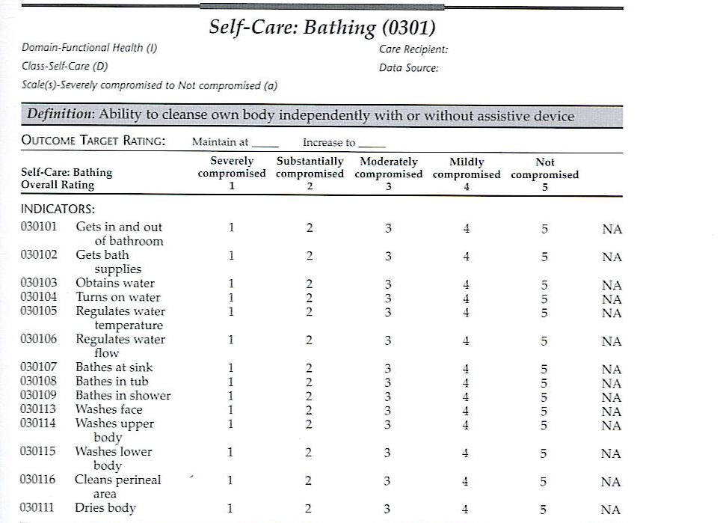

Scan of page from: Johnson, 2004.

Screenshots
Not applicable.

References

Projects:
None.

Literature:

Johnson, M., Moorhead, S, Maas, M., (2004) Nursing Outcomes Classification (NOC) St. Louis, Missouri: Mosby
Kruijswijk Jansen, J., Moster, H. (1994). Het verpleegproces. Utrecht: Lemma

Vocabulary:
SNOMED CT 2.16.840.1.113883.6.96
LOINC 2.16.840.113883.6.1
ICNP 2.16.840.1.113883.6.97 (Obtained on 22-12-2009, from http://www.oid-info.com/get/2.16.840.1.113883.6.97)
ICF 2.16.840.1.113883.6.254
NOC: 2.16.840.1.113883.6.16
NIC 2.16.840.1.113883.6.15
NANDA 2.16.840.1.113883.6.20
Omaha 2.16.840.1.113883.6.98
It is possible that people in this domain use different coding and value sets that used in this DCM. In that case, we as developers appreciate it if we were to be informed.
For the coding the use of terminologies like SNOMED CT and/or LOINC, or one of the classifications of the WHO family of classifications (for example ICD10, ICF, ICNP) has been preferred. The codes that are used are, by our opinion the best possible match between the data item (variable and/or value)and the concept/ concepts as set out in the terminology or classification. It is possible that a very rigorous analysis of one of these terminologies variations emerge that are just as good or even a better match, for instance if another perspective is chosen. There is a small chance that in the future codes for certain data items are being altered. Where we did not find a code, for now, Results 4 Care codes where made and missing concepts will be asked to SNOMED CT.

Remarks
The choice whether speaking of self care, self-help or limitations is up to the nurses or care providers themselves. Often this has to do with the vision and policy of the care facility. The consistent use of these terms throughout the care process in an individual facility is the responsibility of the facility itself.

Disclaimer
Results 4 Care B.V. gives the utmost care to the reliability and timeliness of data in this DCM, Detailed Clinical Model. Errors and inaccuracies may occur. Results 4 Care is not responsible for damages resulting from errors or inaccuracies in the information, nor for damages arising from problems caused by, or inherent in the spreading of information via the Internet, as failures or interruptions from either errors or delays in the distribution of information or services by Results 4 Care, by means of the website repository or by e-mail, or otherwise electronically.
Results 4 care does not accept responsibility for possible damage suffered as a result of the use of data, advise or ideas provided by way of this DCM. Results 4 Care does not accept responsibility for the content of information in this DCM to which or from which using a hyperlink or otherwise, is referred.
In case of contradictions in the mentioned DCM documents and files the priority of the relevant documents is stated by the most recent and highest version mentioned in the revision (version management).
In case information that is included in the electronic version of this DCM is also provided in writing, in case of textual differences the written version will determine. This applies if the version description and date of both are equal. The definitive version has priority over a concept version. A revised version has priority over a previous version.

UML

Patient, client, care taker

